Business Requirement (Project Requirement):
Create an ALV Interactive GRID Report, Smartform, Adobe form as per following requirement.

Selection Screen / Input Screen:
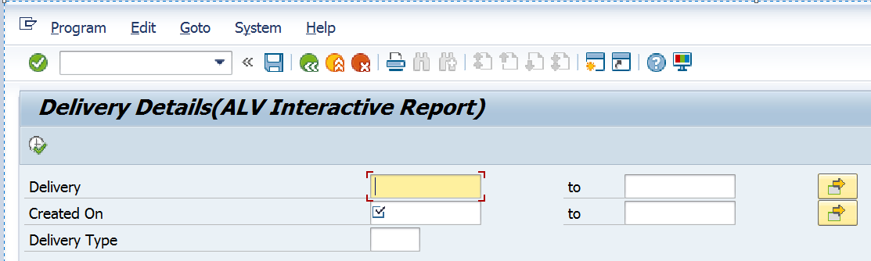

Input fields: Table and fields for reference:
Delivery = LIKP-VBELN
Created On = LIKP-ERDAT Mandatory field
Delivery Type = LIKP-LFART.

Pls. Note:
- Do not use 'PARAMETERS' statement.
- Please create same to same selection screen as shown above.

ALV Output Screen:
Pls. Note: Use FM - REUSE_ALV_GRID_DISPLAY and manual fieldcatalog.
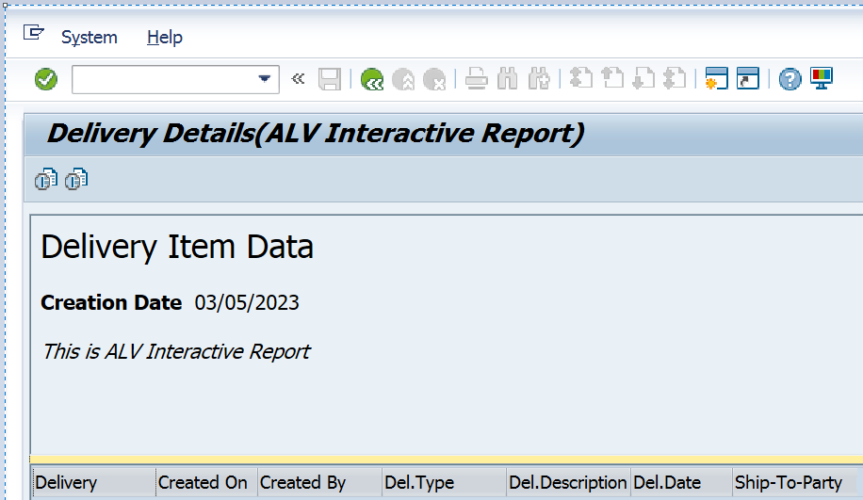
Output fields for basic list: Table and fields for reference:
Delivery = LIKP-VBELN
Created On = LIKP-ERDAT
Created By = LIKP-ERNAM
Del. Type = LIKP-LFART
Del. Desc. = TVLKT-VTEXT
Del. Date = LIKP-LFDAT
Ship-To-Party = LIKP-KUNNR

Imp point: Please ignore the data shown in the sample output, you need to display the data which is available in the system.

Pls. Note:
- Create two buttons in Application Toolbar (as shown below) with the help of PF Status.

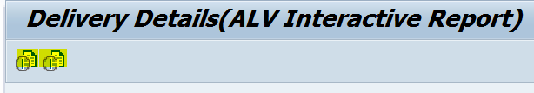

- Write following Page Header with the help of "TOP OF PAGE".
Hint: Call FM - REUSE_ALV_COMMENTARY_WRITE inside TOP OF PAGE subroutine.

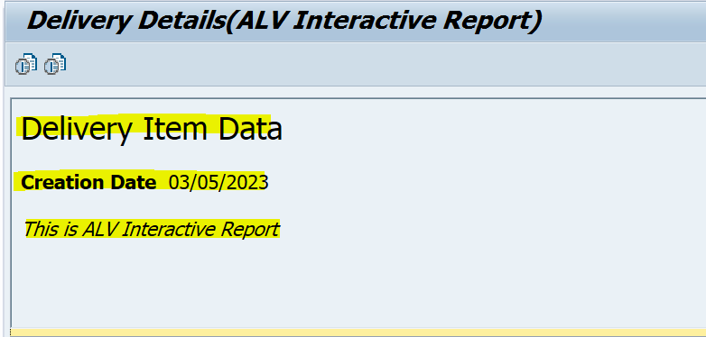

- Activate "BACK" button in Standard Toolbar inside PF Status. When user press this button, go back to Selection Screen.

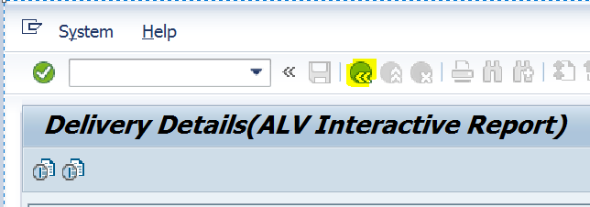

- Assign short key Shift+F1 to Ascending button, Shift+F2 to Descending button.

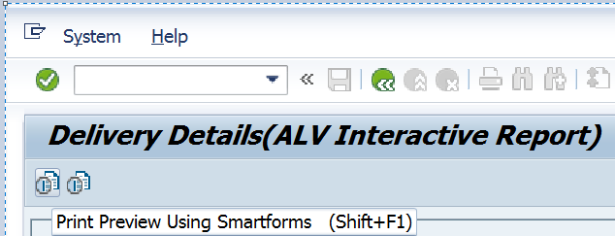

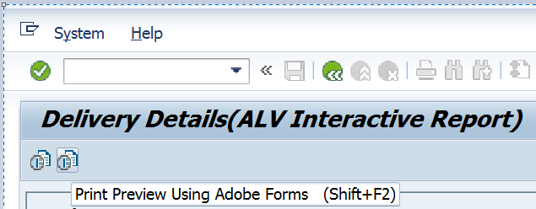

- When user press 1st button (Ascending) or Shift+F1 the output must display using smartforms, when user press 2nd button (Descending) or Shift+F1 the output must display using Adobe forms.

- When no data found for given inputs on selection screen, display message like following. When user press "Continue / Enter" button on message window, go back to selection screen.
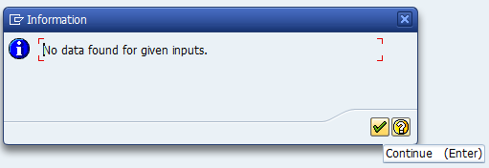

- Create a Transaction Code for your Program.

